Bahria University,

Karachi Campus



LAB EXPERIMENT NO.

**08**

LIST OF TASKS

|  |  |
| --- | --- |
| TASK NO | OBJECTIVE |
| **1** | Write a program to print table of 2 in MIPs Architecture. |
| **2** | Write a program to add all these Numbers 1 , 2 , 3 , 4 , 5 , 6 , 7 |
| **3** | Write a program in MIPS assembly language that takes input and display whether number is prime or not. |
| **4** | Write a program in MIPS assembly language that provide the sum from 1 to 99 using for Loop. |  |
|  |  |
|  |  |
|  |  |
|  |  |

Submitted On:

Date: 05/12/2022

**Task No 1 :** Write a program to print table of 2 in MIPs Architecture.

**Solution :**

la $a0,tab # print tab

li $v0,4

syscall

move $a0,$t3

li $v0,1

syscall

la $a0,tab1 # print tab

li $v0,4

syscall

subi $t0,$t0,1

b true

exit:

li $v0,10

syscall

la $a0,prompt1

li $v0,4

syscall

li $v0,5

syscall

move $t5,$v0

true:

bgtz $t0,lop

b exit

lop:

addi $t1,$t1,1

mul $t3,$t1,$t5

move $a0,$t1

li $v0,1

syscall

.data

prompt: .asciiz "Enter lenght for table: "

prompt1: .asciiz "Enter table : "

tab: .asciiz " : "

tab1: .asciiz "\n"

.text

.globl main

main:

la $a0,prompt

li $v0,4

syscall

li $v0,5

syscall

move $t0,$v0

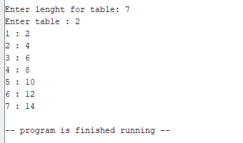**Output:**

**Task no 2 :** Write a program in MIPS assembly language that takes input and display whether number is prime or not.

**Solution :**

.data

input: .asciiz "Enter any number = "

notPrime: .asciiz "This number is not prime number"

prime: .asciiz "This is Prime Number"

.text

.globl main

main:

li $s0,2 #s0 ==> i

la $a0,input

li $v0,4

syscall

li $v0,5

syscall

move $t0,$v0 #t0 user input(n)

blt $t0,$s0,notprime

div $t0,$s0

mflo $t1 #t1 ==> loop n/2

b condition

condition:

ble $s0,$t1,enterLoop

la $a0,prime # this prime number

li $v0,4

syscall

b exit

enterLoop:

div $t0,$s0 #n/i

mfhi $t2 #t2 ==> 0 or 1

beqz $t2,notprime

addi $s0,$s0,1

b condition

notprime:

la $a0,notPrime

li $v0,4

syscall

b exit

exit:

li $v0,10

syscall

**Output :**

**Task No 3 :** Write a program in MIPS assembly language that provide the sum from 1 to 10 using for Loop.

**Solution :**

.data

input: .asciiz "Adding of from 1 to 10 Numbers is \n"

.text

.globl main

main:

la $a0,input

li $v0,4

syscall

li $t0,10

la $a0,0

loop:

add $a0,$a0,$t0

subi $t0,$t0,1

bgez $t0,loop

li $v0,1

syscall

li $v0,10

syscall

**Output :**

**Task 4 : Write a program in MIPS assembly language that provide the sum from 1 to 99 using for Loop.**

**Solution :**

.data

promt:.asciiz"Enter number : "

line:.asciiz"\n"

.text

.globl main

main:

li $v0,4

la $a0,promt

syscall

li $v0,5

syscall

move $t3,$v0

li $t0,0

li $t1,1

loop:

add $t0,$t0,$t1

move $a0,$t0

li $v0,1

syscall

li $v0,4

la $a0,line

syscall

addi $t1,$t1+1

blt $t1,$t3,loop

li $v0,10

syscall

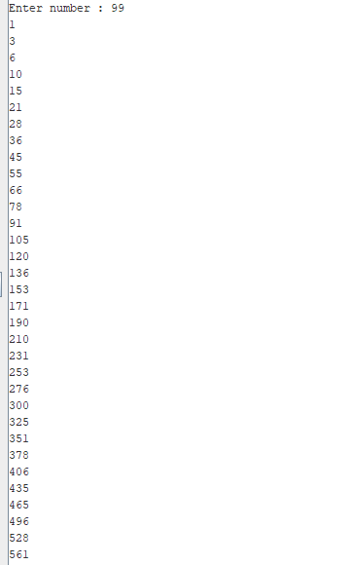**Output :**

